Algal Bloom Prediction Using Advanced Machine
Learning Algorithm
Summer Research Fellowship 2026
Indian National Centre for Ocean Information Services (INCOIS), Ministry of Earth Sciences, Hyderabad
Prepared by: Anshika Chauhan | Mentor: Dr. Kunal Chakraborty

Abstract
This report presents the progress made during the first four weeks of my Summer Research Fellowship at INCOIS, focused on developing an advanced machine learning based approach for algal bloom prediction. Algal blooms are environmental events resulting from quick multiplication of phytoplankton species over a short period of time, phytoplankton are microscopic plant like organisms that form the base of the marine food web. During the first month of my internship at INCOIS, I developed a comprehensive understanding of Algal Bloom prediction through an extensive literature review and analysis of existing forecasting methodologies. Reviewed several machine learning and deep learning approaches. After receiving and preprocessing the satellite datasets, I carried out exploratory data analysis, including bloom distribution analysis, seasonal variation, variable relationships, and missing data analysis. I generated the phytobloom target variable for the Northern Arabian Sea and investigated strategies such as clustering and DINEOF to address large data gaps. Subsequently, I formulated the bloom prediction problem as a multi-class classification task, developed and evaluated XGBoost5 model, performed feature engineering, analysed model confidence using class probabilities, conducted hyperparameter tuning using Optuna, and assessed model generalization. Additionally, I compared predictions using MODIS, OCCI, GLORYS, and gap-free chlorophyll datasets, improved visualization of bloom probability maps, generated error maps and temporal animations.
In the remaining duration of the internship, I plan to extend the current analysis to the Kerala region by following a workflow similar to that used for the Northern Arabian Sea, including data preprocessing, exploratory analysis, feature preparation, model training, and evaluation. I also intend to compare the performance of different machine learning models to identify the most suitable approach for Algal Bloom prediction. Additionally, I will explore further feature engineering, hyperparameter tuning, and other possible improvements that may enhance the model's predictive performance and generalization.

Problem Statement
To develop an advanced machine learning based framework for predicting algal bloom occurrence using satellite-derived environmental variables, enabling more accurate and timely bloom forecasting for selected regions of the Indian Ocean.

Data Preparation
The study focuses on the Northern Arabian Sea, bounded approximately between 19°N–23°N latitude and 62°E–67°E longitude. Data was sourced from the MODIS satellite (NASA Ocean Biology Processing Group) as daily files at 4 km resolution, spanning 2003 to 2025 (approximately 8,344 daily files). Each file provides spatial maps of eight oceanographic variables: chlorophyll-a (CHLOR_A), sea surface temperature (SST), photosynthetically active radiation (PAR), KD490, particulate organic carbon (POC), absorption by dissolved organic matter (ADG), absorption by phytoplankton (APH), and PhytoID, which identifies the dominant phytoplankton species present. The target variable, Phytobloom, was derived by combining chlorophyll-a with PhytoID: a pixel was classified as a bloom only if chlorophyll-a exceeded 1 mg/m³ and the species was confirmed via PhytoID, giving three classes — Class 0 (non-bloom), Class 1 (Noctiluca bloom), and Class 2 (diatom bloom).
A major challenge was extensive missing data: during July, August, and September, 95–100% of observations were missing due to persistent monsoon cloud cover blocking the optical sensor. Since the gaps were too large and continuous to justify interpolation or DINEOF reconstruction, only valid, directly observed data points were retained. After removing pixels with missing chlorophyll-a, SST, or PAR, roughly 22 million of the original 96 million observations remained (23% retention) — still sufficiently large for robust model development. The dataset was split chronologically: 2003–2023 for training (further divided into learning and validation subsets) and 2024–2025 as an independent test set.

Methodology
Exploratory analysis showed an average of 100 bloom days per year, with clear seasonal patterns and considerable interannual variability, and confirmed the seasonal concentration of missing data during monsoon months. A correlation analysis found that the variables most strongly related to bloom occurrence were also the ones with the highest missing data proportion, while more consistently available variables had weaker correlations. K-Means clustering was attempted to group pixels by similar annual bloom behaviour, but the resulting clusters mainly reflected geographic separation rather than behavioural similarity, and this approach was not carried forward.
Feature importance from an initial baseline model showed chlorophyll-a as by far the most influential predictor, with SST and PAR contributing minimally. To better capture spatial and seasonal structure, latitude and longitude (min-max scaled to -1 to 1) and cyclical sine-cosine encodings of month and day of year were added, since calendar variables are periodic and a plain numeric scale would wrongly separate, for example, December and January.
XGBoost, a gradient boosted decision tree algorithm, was selected as the primary model for its ability to capture non-linear relationships, efficiency on large datasets, strong generalization, and built-in feature importance. Because bloom classes are imbalanced, Macro F1-score was used as the primary evaluation metric alongside accuracy, precision, and recall, ensuring the minority bloom classes were weighted equally with the majority non-bloom class. The model was then tuned across n_estimators, max_depth, learning_rate, subsample, colsample_bytree, gamma, alpha, and lambda, with the objective of maximizing Macro F1-score while keeping training and testing performance closely aligned to avoid overfitting.
Finally, the trained model was applied to MODIS chlorophyll observations as well as GLORYS-predicted chlorophyll, OCCI chlorophyll, and gap-free chlorophyll datasets to evaluate prediction consistency across different data sources. Spatial prediction maps, confidence maps, error maps, temporal animations, and representative monthly case studies were generated for detailed qualitative assessment.

Result
The initial baseline XGBoost model reliably separated bloom from non-bloom pixels but struggled to distinguish Noctiluca from diatom blooms.
Three rounds of hyperparameter tuning were carried out; results are summarized in Table 1.
Tuning Round | Train Macro F1 | Test Macro F1 | Gap
1st Tuning | 0.9477 | 0.9085 | 0.0392 (3.9%)
2nd Tuning (Final Model) | 0.9320 | 0.9171 | 0.0148 (1.5%)
3rd Tuning | 0.9356 | 0.9152 | 0.0204 (2.0%)
Table 1: Train and test Macro F1-scores across three hyperparameter tuning rounds.
The smaller the gap between train and test Macro F1, the better the model generalizes. The first tuning round had the highest training score but also the largest gap and lowest test score, indicating mild overfitting. The second round produced the smallest gap and the highest test score, and was selected as the final model; the third performed comparably but slightly behind the second.
The final model showed closely aligned training and testing performance, confirming good generalization. Using this model, spatial bloom prediction maps were generated for all 337 days in the test set and compared against actual observations, and one representative day per month was analysed in detail using actual maps, predicted maps, and pixel wise error maps.
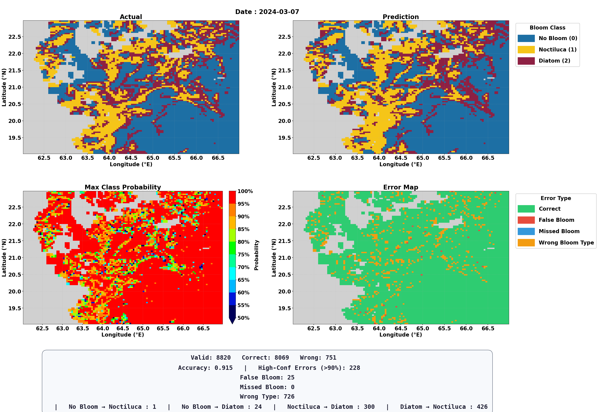
Overall, the model reliably distinguished bloom from non-bloom conditions, with the main remaining limitation being finer discrimination between the two bloom types.
Comparisons between predictions obtained using MODIS, GLORYS, OCCI, and gap-free chlorophyll datasets revealed noticeable differences, particularly for the OCCI dataset, which generally exhibited lower chlorophyll concentrations and reduced spatial coverage. These observations highlighted the influence of input data characteristics on model predictions and identified areas for further investigation.

Conclusion
This study demonstrated the potential of machine learning for algal bloom prediction in the Northern Arabian Sea, using over two decades of MODIS satellite observations. Despite significant monsoon-driven missing data, careful feature engineering and hyperparameter tuning produced a well-generalized XGBoost model, achieving a test Macro F1-score of approximately 0.92 and reliably distinguishing bloom from non-bloom conditions, though finer discrimination between bloom types remains an area for improvement. Comparing predictions across MODIS, GLORYS, OCCI, and gap-free chlorophyll datasets showed that the latter three systematically underrepresent bloom peaks relative to MODIS, confirming MODIS as the most reliable source for bloom detection. These findings provide a strong foundation for extending the approach to the Kerala region and evaluating alternative models in the next phase of the fellowship.

*Declaration
The full version of this report has been uploaded as a softcopy at the Academy's site.
During the preparation of this work, I used Chat Generative Pre-Trained Transformer (ChatGPT; OpenAI, San Francisco, CA, USA) alongside Claude (Anthropic) to enhance readability and language, aiding in formulating and structuring content. After using this tool, I reviewed and edited the content as needed and take full responsibility for the content.

